Brentwood  Science  Magnet  An award winning elementary school open to all students who reside within the LAUSD school boundaries.  K5 Science Integration Specialists provide every student in Grades K-5 with hands-on labs in Earth, Physical, Life and Computer Sciences, there truly is no other program like ours in all of LAUSD. This carefully designed Science focus began decades ago and continues to be at the forefront of today's Presidential STEM Initiative.  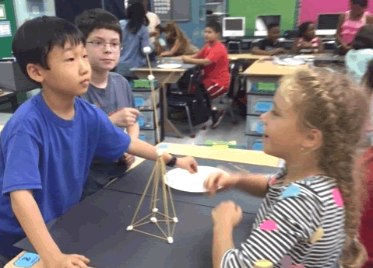 |  |  | Brentwood Science Magnet Elementary  740 S. Gretna Green Way  Los Angeles, CA 90049 |  | Brentwood  Science  Magnet  - Empowering Students to Meet  - Challenges with Success

Our Community Partners  We have achieved this wonderful success by collaboration between parents, teachers, administration, and the local community. With such partners as Brentwood Green, YMCA, Tree People, and the Anne and Kirk Douglas Playground Foundation, our students receive the benefit of learning in top notch surroundings. The Friends of BSME helps support art and music programs. Despite the recent budget cuts, all parties remain strong in their commitment to our students. | “We had our daughter in a private preschool and were worried about the transition to a large public school. It was the best decision we made. She is thriving academically and socially with diverse friends from a variety of backgrounds.”  ~ Parent  greatschoools.org  What We Do Best  We are an 800+ Honor School. Our children learn, play and grow together, regardless of individual backgrounds. We pride ourselves on developing educated students, who are  also becoming better, more well-rounded people every day.  We, the families, teachers and staff of BSME are extremely proud of our school and invite you to visit. |  | Key Offerings  - Implementing NGS Standards  - Four dedicated science labs  - Computer science  - Earth science  - Life science  - Physical science  - Five computer rooms  - Six acres of green space  - Free transportation  - GATE program  - Chorus  - Orchestra  - Afterschool enrichment  - Before-school YMCA sports  - Urban community gardening  - Parent-Teacher association  Fall Tour Dates  - Thursday, October 6 at 9 am  - Thursday, October 13 at 1:30 pm  - Thursday, October 20 at 9 am  - Thursday, October 27 at 1:30 pm  - Thursday, November 3 at 9 am  Contact Us  Brentwood Science Magnet Elementary  740 S. Gretna Green Way  Los Angeles, CA 90049  Telephone (310) 826-5631  brentwoodsciencetigers@gmail.com  www.brentwoodsciencemagnet.org/

